|  |
| --- |
| **BIGSCREEN**  ***A Mini Project Report on***  **Online Movie Ticket Booking System**  **T.E. - I.T Engineering**  **Submitted By**  **Rohin Ambati 20104068**  **Karan Maurya 20104070**  **Rupesh Mishra 20104100**  **Under The Guidance Of**  **Prof. Manasi Choche**    **DEPARTMENT OF INFORMATION TECHNOLOGY**  A.P.SHAH INSTITUTE OF TECHNOLOGY  G.B. Road, Kasarvadavali, Thane (W), Mumbai-400615  UNIVERSITY OF MUMBAI  **Academic year : 2022-23** |
| **CERTIFICATE**    This to certify that the Mini Project report on BIGSCREEN has been submitted by **Karan Maurya**(20104070), **Rohin Ambati** (20104068), and **Rupesh Mishra** (20104100) who are Bonafide students of A. P. Shah Institute of Technology, Thane, Mumbai, as a partial fulfilment of the requirement for the degree in **Information Technology**, during the academic year **2022-23** in the satisfactory manner as per the curriculum laid down by University of Mumbai. Prof. Manasi Choche Guide  **Prof. Kiran Deshpande** **Dr. Uttam D.Kolekar**  Head Department of Information Technology Principal  External Examiner(s)  1.  2.  Place: A.P.Shah Institute of Technology, Thane  Date:  **ACKNOWLEDGEMENT** This project would not have come to fruition without the invaluable help of our guide Prof. Manasi Choche . Expressing gratitude towards our HoD, Prof. Kiran Deshpande, and the Department of Information Technology for providing us with the opportunity as well as the support required to pursue this project. We would also like to thank our teacher Ms. Yaminee Patil who gave us her valuable suggestions and ideas when we were in need of them. We would also like to thank our peers for their helpful suggestions. **ABSTRACT**  The proposed project “Online Movie Ticket Booking System” is the process whereby consumers directly buy movie tickets online from a multiplex website interactively in real time without an intermediary service over the internet. The given System provides the detailed working of the Online Movie Ticket Booking processing and what all happens whenever we or any one of us goes to book movie tickets online. “Online Movie Ticket Booking System” is an online ticket booking project & customers can book tickets 24 hours a day from anywhere in the world and interact with multiplex’s website to know about currently running movies and their schedule or service information provided by the multiplex. Multiplex customer relationship manager can interact with customers and enable them to learn more about customers’ needs & build good customer relationships and increase efficiency and reduce costs & and gain access to national markets quickly. |

|  |
| --- |
| **TABLE OF CONTENTS**   1. Introduction……………………………………………………………………..1    1. Purpose......................................................................................................... 1    2. Problem Statement………………………………………………………...2    3. Objectives.......................................................................................................2    4. Scope........................................................................................................ 3 2. Literature Review………………………………………………………………...4 3. Proposed System……….........................................................................................7    1. Features and Functionality………………………………………………7 4. Requirements Analysis......................................................................................... 9 5. Project Design.......................................................................................................10    1. Use Case diagram……………………………………………………… 10    2. DFD (Data Flow Diagram) ……………………………………………..11    3. System Architecture……………………………………………………..20 6. Technical specification……………...…………………………………………...13 7. Project Scheduling.................................................................................................15 8. Implementation…………………………………………………………………..16   9. Result and Discussion…………………………………………………………….17   1. Conclusion and Future Scope.................................................................................18     References |

**CHAPTER 1**

**Introduction:**

This project is aimed at developing a ticket reservation system for Cinema Halls. The ticket reservation system is an internet-based application that can be accessed by anyone who has an internet connection. This application will automate reservation of tickets and enquiries about the availability of seats .This application includes E- mail confirmation for tickets. It also has a in built transaction gateway which gives customers hassle free payment experience, as earlier the customer had to stand in a queue to get his/her movie ticket’s as well as make payments to solve this problem we thought of making this movie ticketing system. The customer will also receive-mail of his/her ticket’s as well as receipts. We also reward people by giving certain rewards may it be cashbacks or some hampers which will also increase our brand loyalty. We want to provide customers with a good experience and resolving our customers issues hold upmost value for us.

In case the customer wants to cancel his/her reservation he can do it by cancelling it directly from the appropriate E-mail us at our customer service ID.

**Purpose:**

The traditional way of booking the ticket for the movie is the customer needs to go to the specific theatre where the desired movie was playing and stand in long queue and buy the ticket which consume slot of time. To help the customer to avoid wasting time, book tickets and so look at the availability of the seats was our main purpose.

To give transparency to our customers we have an integrated payment gateway, thus providing our customers with hassle-free service. Customer can email us their issues which will be solved by us as soon as possible thus giving up most satisfaction to our customers. If people wish to cancel the booking same can be done by our system as early customers couldn’t do this. If a customer is having any doubt regarding anything they can email us that will be solved by our team. Customer can use his/her bank details google pay,

Paytm and other transaction apps according to their convenience which provides hassle free transactions experience to our customers.

### Problem Definition:

The old manual system was suffering from a series of drawbacks. Since whole of the system was to be maintained with hands the process of keeping, maintaining and retrieving the information was very tedious and lengthy.

There cords were never used to be in a systematic order. There used to be lots of difficulties in associating any particular transaction with a particular context. There would always be unnecessary consumption of time.

There as on behind it is that there is lot of information to be maintained and have to be kept in mind while running the business .For this reason we have provided features Present system is partially automated (computerized), actually existing system is quite laborious. Thus, giving customers and the theatre administrator’s value for their time.

**Objectives:**

* The main objective of the Project on Online movie ticket’s booking system is to manage the details of customer. Provide them the list of theatres where the movie is playing.
* It manages all the information about Theatres, Transaction details and Seats availability.
* The project is totally built at administrative end and thus only the administrator is guaranteed the access.
* The purpose of the project is to build an application program to reduce the manual work for managing the seats, transactions, now-playing movies.
* It tracks all the details about the customer’s login details, transaction details and grievances.
* Manage the information of booking.
* Manage the information seats
* Integrations of all records of shows.
* Editing, adding and updating of records is improved which results in proper resource management of seats data . Saving information about customer i.e. name, preferred location etc., so need to add the information again.

**Scope :**

It may help collecting perfect management in detail. In a very short time, the collection will be obvious, simple and sensible. It will help a person to know public and critics reviews. It also helps in current all works relative to online movie ticket’s booking system. It will reduce the cost of cash handling as everything is digitalized and collection procedure will go on smoothly. Our project aims at Business process automation, i.e., we have tried to computerize various processes of Movie Ticketing .To save customer’s valuable time. In computer system, it is not necessary to create the manifest, but we can directly print it, which saves our time .To assist the staff in capturing the effort spent on the irrespective working areas. To utilize resources in an efficient manner by increasing their productivity through automation. The system generates types of information that can be used for various purposes. It satisfies the user requirement. Be easy to understand by the user and operator Be easy to operate Have a good user interface Be expandable

* Giving customers certain rewards thus increasing loyalty of customers towards us.
* Customers can make transactions online via their bank or any other UPI app
* To assist and help customers to help them solve their issues/doubts.
* To give them complete information regarding the movie i.e., locations’ time etc.

**Chapter 2**

**Literature Review**

1. **Research gate ( Punyaslok Sarkar )**

Customers may view the contents of any movie show at any time and may book any movie ticket as needed. The program automatically calculates the subtotal and grand total. When a visitor decides to finally book the ticket, the order information including the buyer's name, address and billing instruction is stored in the database securely and payment has been made. The combo booking is also provided at the time of booking the ticket and there’s a wonderful facility of delivering the combos at your seat when you are watching the movie.

1. **Academia ( Ratik Kumra )**

All customers’ detailed information will be stored in the database, and they will be given unique account numbers. The system will provide facility of adding new customer record, updating old customer records and deleting any customer record .This information is further used by all the modules as required. The customer record is very important in the project. This customer record will be used by the project everywhere it is needed. All seat allocation and ticket booking is done here. This module takes customer details and show date time and allocate seats and calculate booking amount, which is further used for payment % ticket printing. In payment % ticket print scenario the system prepares ticket based on the information given by the seat allocation % ticket booking module. This is the final process of ticket booking process.

1. **The journals house ( freeprojectz.com )**

This paper deliberates Movie Ticket Booking System which helps as a valuable platform for customers and employees. The paper contains of compensations and numerous application practices of the portal and the skills used to appliance the system. The project consists of various modules in which the Theatre module manages the functioning of the movie screening, the User module is meant for booking tickets, the administrative module manages the administrative operations, and the Transaction module manages the transaction issues. The foremost objective of developing this project is to automate the process and simplify it. The portal provides all the basic functionalities of the modern-day multiplex. The portal is very user friendly and cost effective.

**Chapter 3**

**Proposed System**

* Security of Data

We understand the word of data security hence we have made it in a way that the customer data will be safe from unauthorized access and corruption is prohibited.

* Ensure Data Accuracy

To ensure data accuracy we have made it fully password protected which can only be access by the respected user no one can else see the data of other customers.

* Proper Control of Higher Officials

As we know customer get frustrated if he had to stuck somewhere while doing online booking. Especially while doing the payment hence, we have made sure that he doesn’t have to face the issues.

* Minimize Manual Data Entry

In this ongoing generation everything is fast, and people want their task should be done within a minute. But if they have to fill the same details everywhere they just get fade up of it and even may leave the page, so we have minimized the data entry everywhere and make it customer friendly.

* Greater Efficiency

As we know increase in technology has made various options for customer they will only opt for where they find great efficiency and easy tasking.

* Minimum time needed for the various processing

As people want everything within a second and as fast as possible making them wait for the long time make them least interested on the selected things so we have made it fast.

**Features and Functionality:**

* Transaction Module: Used for managing the details of Transaction’s made by the customer.
* Record Module: Used for managing the details of Record.
* Management Module: Used for managing the information and details of the Upcoming running movies.
* Seats Module: Used for managing the Seats info.
* Login Module: Used for managing the login detail.
* Users Module: Used for managing the users.

**Chapter 5**

Project Design:-

In this phase, a logical system is built which fulfils the given requirements. Design phase of software development deals with transforming the client’s requirements into a logically working system. Normally, design is performed in the following in the following two steps:

**Primary Design Phase:**

In this phase, the system is designed at block level. The blocks are created on the basis of analysis done in the problem identification phase. Different blocks are created for different functions emphasis is put on minimizing the information

flow between blocks. Thus, all activities which require more interaction are kept in one block.

**Secondary Design Phase:**

In the secondary phase the detailed design of every block is performed.

**The general tasks involved in the design process are the following**:

1. Design various blocks for overall system processes.
2. Design smaller, compact and workable modules in each block.
3. Design various database structures.
4. Specify details of programs to achieve desired functionality.
5. Design the form of inputs, and outputs of the system.
6. Perform documentation of the design.
7. System reviews.

System Architecture:-

Flowchart

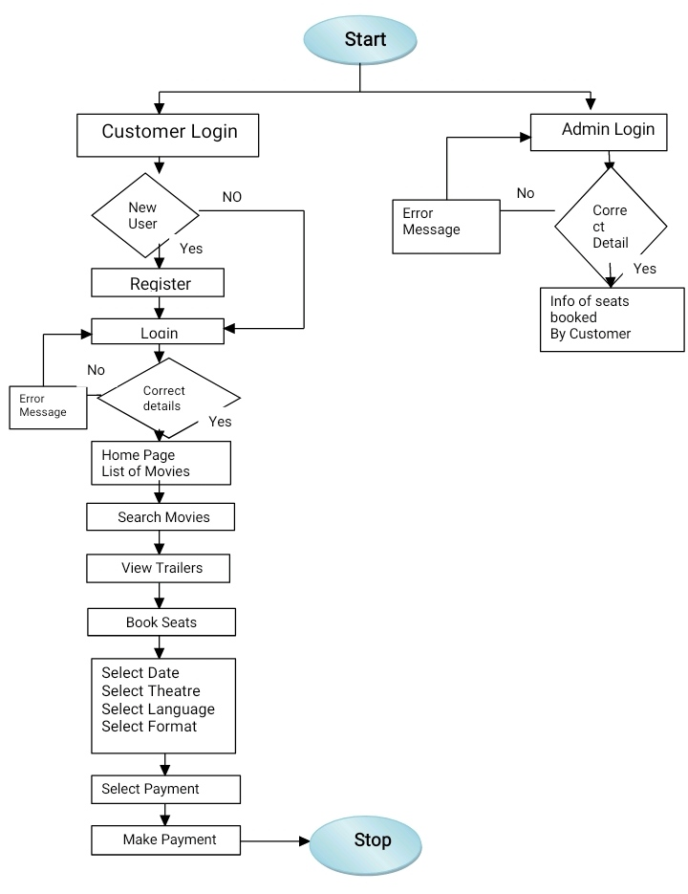

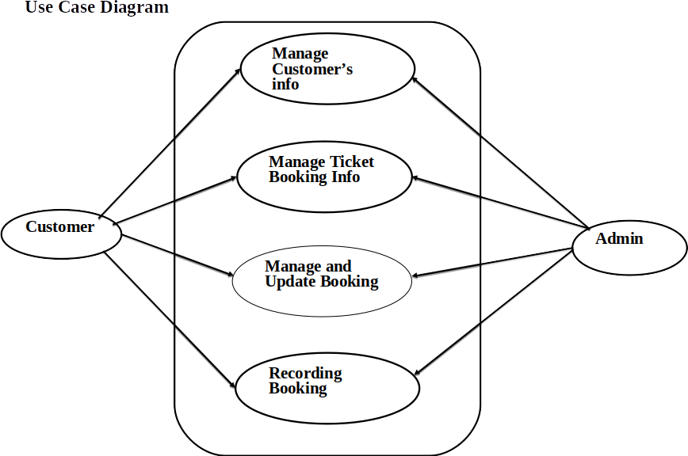



**Chapter 6**

**Technical Specification:-**

**Frontend: Html, CSS, JavaScript :-**

As a web developer, the three main languages we use to build websites are HTML, CSS, and JavaScript. JavaScript is the programming language, we use HTML to structure the site, and we use CSS to design and layout the web page. These days, CSS has become more than just a design language, though. You can actually implement animations and smooth transitions with just CSS.

**OS /Windows :-**

Window is a graphical operating system developed by Microsoft. It allows users to view and store files, run the software, play games, watch videos, and provides a way to connect to the internet. It was released for both home computing and professional works.

**Backend: php, MySQL**:-

With PHP, you can connect to and manipulate databases. MySQL is the most popular database system used with PHP. PHP combined with MySQL are cross platform (you can develop in Windows and serve on a Unix platform) .The data in a MySQL database are stored in tables. A table is a collection of related data, and it consists of columns and rows. Databases are useful for storing information categorically.

# Chapter 10

## Conclusion & Future scope

Our project is only a humble venture to satisfy the needs to manage their project work. Several user-friendly coding has also adopted. This package shall prove to be a powerful package in satisfying all the requirements of the school. The objective of software planning is to provide a framework that enables the manger to make reasonable estimates made within a limited time frame at the beginning of the software project and should be updated regularly as the project progresses.

**At the end it is concluded that we have made effort on following points…**

* A description of the background and context of the project and its relation to work already done in the area.
* Made statement of the aims and objectives of the project.
* The description of Purpose, Scope, and applicability.
* We define the problem on which we are working in the project.
* We describe the requirement Specifications of the system and the actions that can be done on these things.
* We understand the problem domain and produce a model of the system which describes operations that can be perform on the system.
* We included features and operations in detail, including screen layouts.
* We designed user interface and security issues related to system. Finally the system is implemented and tested according to test cases.

**References:-**

1. https://www.researchgate.net/publication/342466860_A_PROJECT_ON_ONLINE_TICKET_BOOKING_SYSTEM.
2. <https://www.academia.edu/36099864/Online_Movie_Ticket_Booking_System>
3. <https://www.freeprojectz.com/project-report/3053>

[1] Roy, Archit, Vinit Shahdeo, and Rajesh Kaluri. "A Comparative Study in Online Movie Ticket Booking System." Research Journal of Engineering and Technology 10.1 (2019): 16-20.

[2] Tazin, Nur-E. Online Movie Ticket booking System. Diss. United International University, 2018.

[3] Rajouria, Rahul, et al. "Online Cinema Ticket Booking System."

[4] Alam, Md, Md Rouf, and Md Heron. "See My Show (Online Ticket Booking System)." (2019).

[5] Mesfin, Zewdie. Web Based Online Cinema Ticket Booking System For Adama Mormor Cinema. Diss. ASTU, 2015

**Chapter 4**

Requirement Analysis:-

Requirements analysis in systems engineering and software engineering, encompasses those tasks that go into determining the needs or conditions to meet for a new or altered product, taking account of the possibly conflicting requirements of the various stakeholders, such as beneficiaries or users. 9t is an early stage in the more general activity of requirements engineering which encompasses all activities concerned with eliciting, analyzing, documenting, validating, and managing software or system requirements. Requirements analysis is critical to the success of a systems or software project. The requirements should be documented, actionable, measurable, testable, traceable, related to identified business needs or opportunities, and defined to a level of detail sufficient for system design.

**Chapter 9**

Result and Discussion :-

• Administrator has to login to access the system.

• He can add, update or delete details of customers.

• He can search for customers on the basis of their username or E-mail id.

• He can keep an update on available seats and can increase or decrease when ever needed.

• Provides the searching facilities based on various factors. Such as Movie name, Actor name, Director Name, Production unit.

• The movie ticketing System also manage the Record details online for availability of seats, Login id details, Transaction details.

• It tracks all the information of transaction of customers, seats availability, Username etc.

• Manage the information and location of customer.

• Shows the information and description of the upcoming and running movies.

• To increase efficiency of managing.

• It deals with monitoring the information and transactions of transaction.

• Editing, adding and updating of Records is improved which results in proper resource management.

**Chapter 7**

Project Scheduling:-

|  |  |  |  |  |  |  |  |
| --- | --- | --- | --- | --- | --- | --- | --- |
| **Sr. No** | **Group Member** | | **Time duration** | | **Work to be done** | |  |
| **1** | Rohin Ambati | | 2nd week of January | | Implementing Homepage, Description Page,  Seats Page, Connecting Pages,  Debugging, compilation and running of code and solving errors if any. | |  |
|  |  | | 4th week of February | | Payment Gateway. | |  |
|  |  | | Selection of date, theatre Page | |  |
|  |  | | Debugging, | |  |
|  |  | | compilation and running of | |  |
| 2 | Karan Maurya | | code and solving error if any | |  |
|  |  | **3** | Rupesh Mishra | 1st week of April | | Part of Login Page ,  Part of Registration Page and Validation of pages Debugging, Compilation and running code and solving error’s if any. | |
|  |  | **4** | Rohin, Karan, Rupesh | 3rd Week of May | | Part of Homepage Part of Login Page and Admin page ,  Creating and connecting Database  Debugging, compilation and running of code and solving error’s if any. | |

Chapter 8

Implementation:-

